

Requirement Specification Document

OOAD SA41

TEAM 10

Background information of current System:

Get Fresh Food is a supermarket store operating with a large variety of products. The operation of the store has been traditional which requires the employees to take count of stock, order goods and label prices manually. The supermarket is facing lot of problems due to manual errors and human carelessness.

The supermarket follows a hierarchical method of performing tasks with efficient staff working in two shifts.

Current Business System:

The Owner of the supermarket gives instructions for setting product price, update function. Even he can access any report.

The Branch Manager handles many operation of the store i.e. sets the price for each product, classifies the products on the basis of sale and writes special report in case of lost or damaged goods.

The Promoter maintains the goods on display, removes damaged or expired goods from the shelf and replenish with fresh ones. Promoter is required to label each product with a price tag and the shelf..

The Store man prepares goods order list, maintains a set of inventory record for all the goods, returns damaged or expired goods to the supplier and updates the inventory by End-Of-Day.

The Cashier checks products selected by customers, enters price of the products into cash register, collects two receipts of list of items bought by the customer and the total amount payable generated by the cash register, collects money from the customer and keeps the receipts. At the end of their shift, cashier is required to tally the money, collate all the items sold and pass on the End-Of-Day sales record to store men and branch manager.

Problems in the Current Business System:

All the work done by the staff and owner is manual , i.e entry of damages/expired items, making end-of-day sale report ,entry in cash register for sold item etc.

There are many places where human errors are detected like error in price labelling, Monthly inventory check etc.

There is no Centralization of system for the staff. Because of this the store men might consider that any discrepancy could be due to mistake made by the cashiers when they record sales or by the promoters when they withdraw goods from the store.

Solution for current problem:

Providing a Centralized system: which will be accessed by the store as well as supermarket staff, which will reduce the occurrence of discrepancies in sales & inventory record and variation.

A lot of work done by staff should be automatically. There will be less chances of Human Errors and work load.

**Actor List & description:**

|  |  |
| --- | --- |
| **Owner** | He is the sole proprietor of the shop. He will hire branch manager and all his supporting staff. Reviews the business progress using Loss of sales report, daily sales etc., to determine business policies and take necessary actions. |
| **Branch Manager** | Branch manager is in charge of overall smooth running of the business. He is hired by owner and is a full time worker. He is reporting to owner and authorized to check the sales amount at the end of each shift. |
| **Store men** | Store men appointed by branch manager. There are 2 store men who are responsible for the overall maintenance of store levels of the shop inventory. |
| **Promoter** | Branch manager appoints promoters. He is a full time worker, working in shifts. Each promoter will look into set of products & its designated locations. |
| **Cashier** | Cashiers are appointed by branch manager, who work in shifts. Their main duty is to maintain cash register and end-of-day sales book. These two books are very important to hold the profit/loss of the business & draw business strategies accordingly. |

**System use case diagram:**

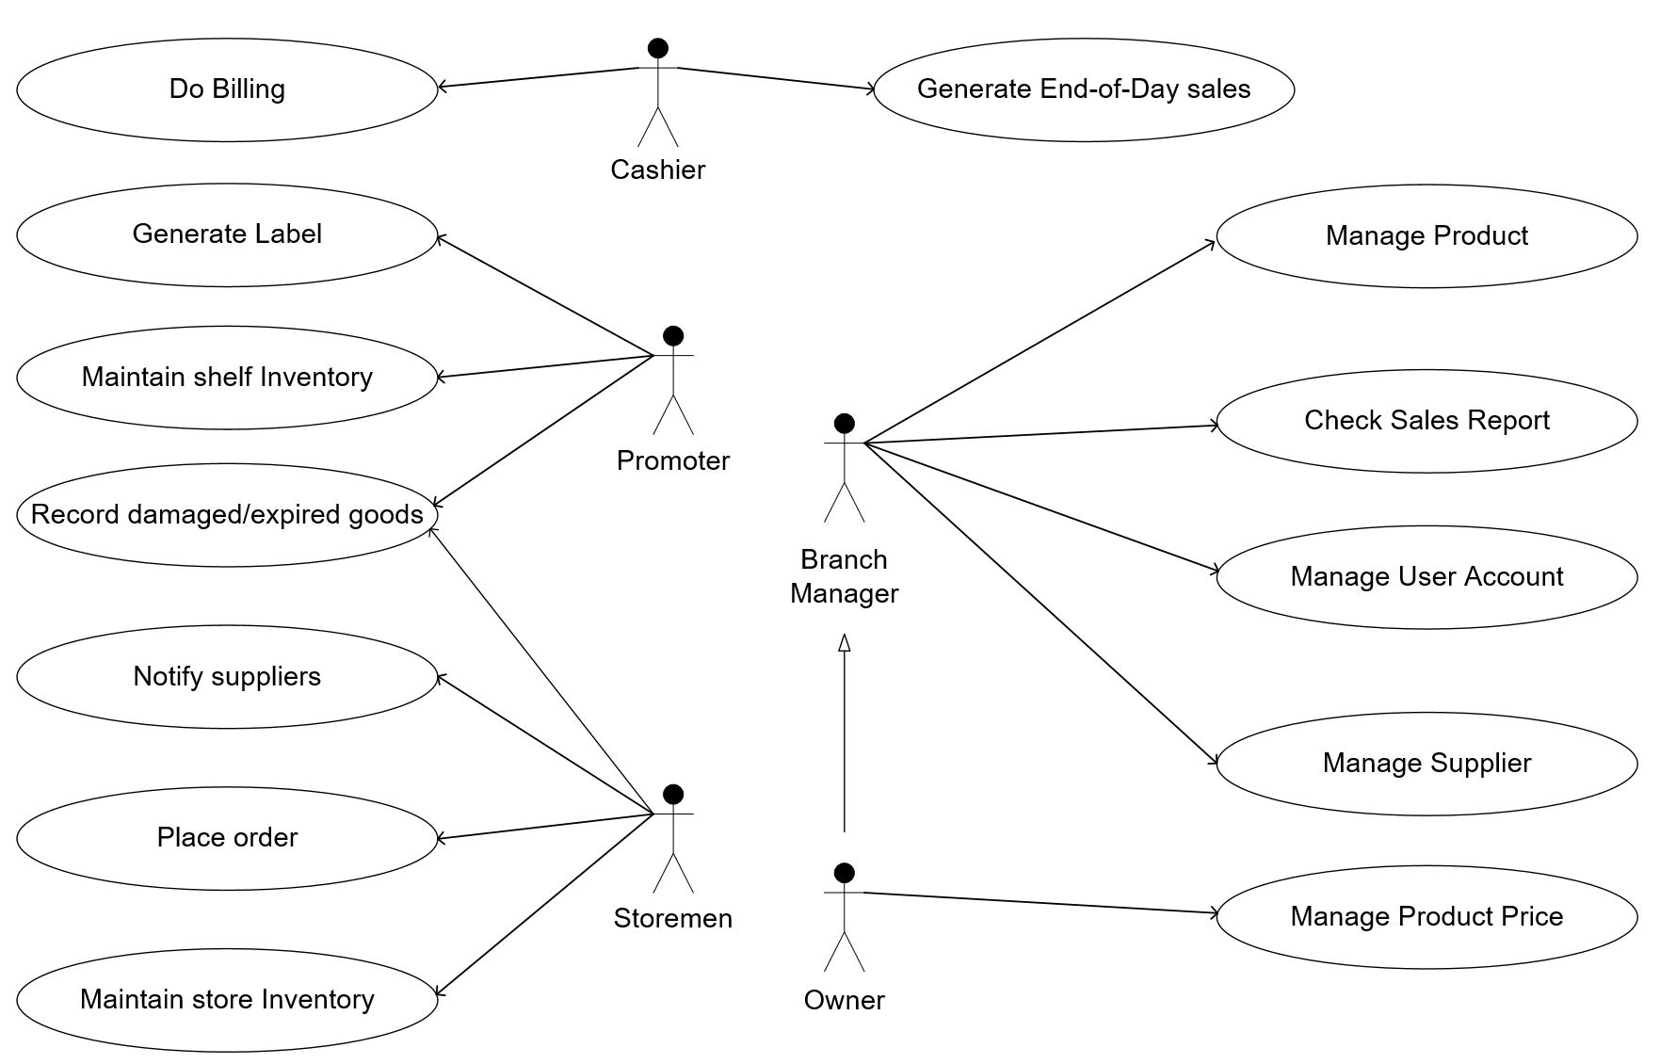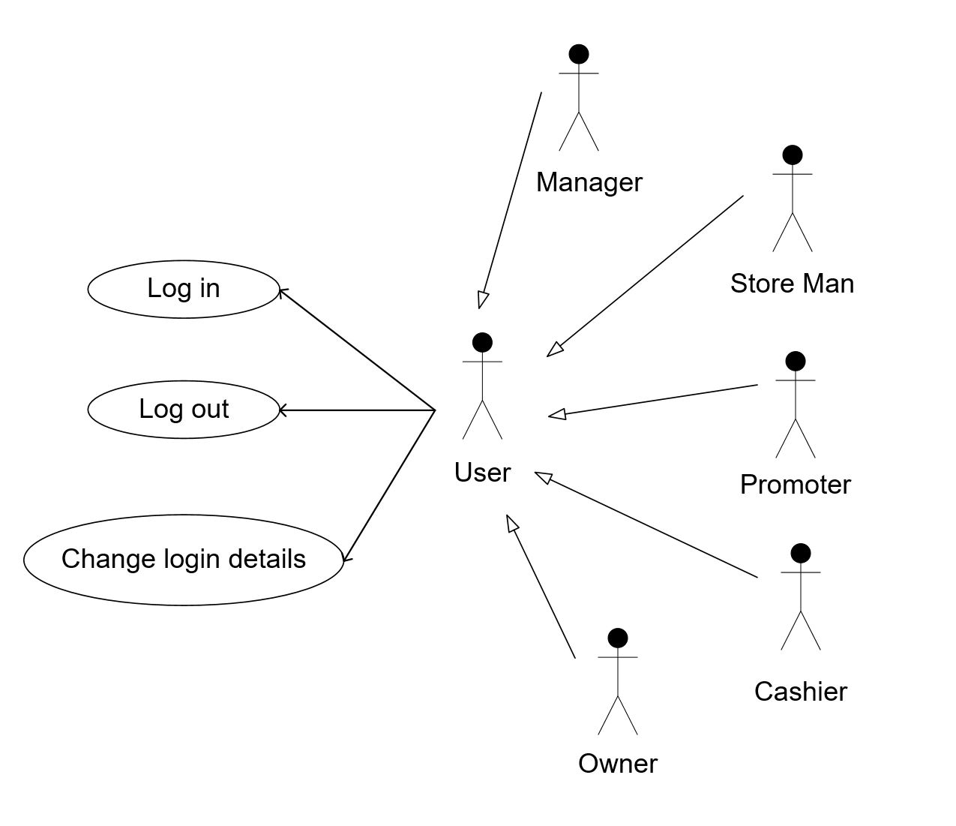

**System domain model:**

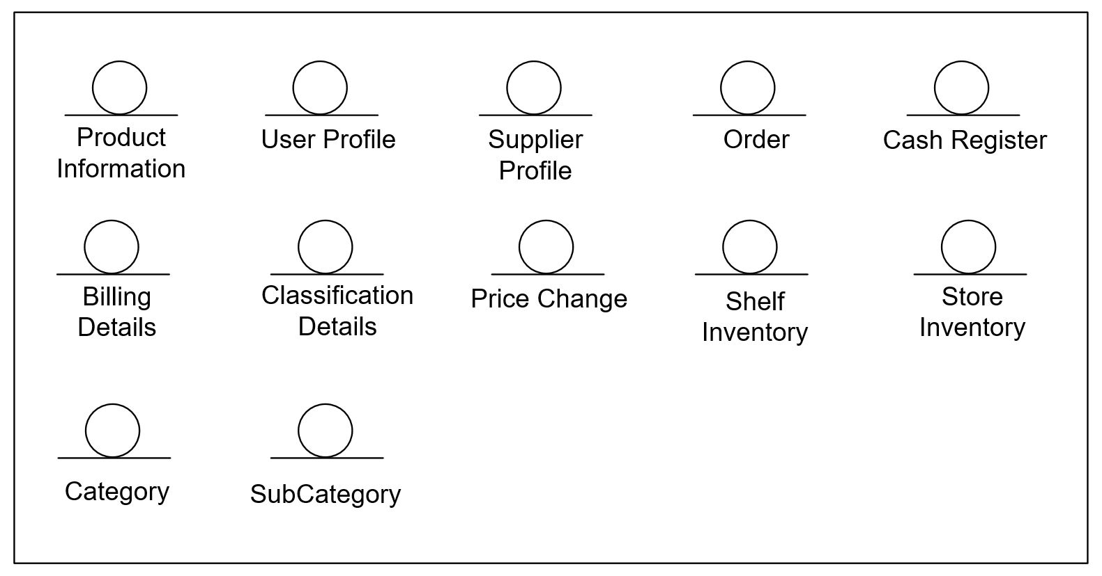

**Business entity:**

|  |  |
| --- | --- |
| **Business entity** | **Description** |
|  | This entity includes product information of product ID, product name, pricing, classification, supplier, category Id, Sub category Id. |
|  | This entity includes every registered staff of the supermarket and the necessary information, e.g. the name, staff ID, address and phone number, password, department. |
|  | This entity includes all the suppliers of the supermarket and the necessary information, e.g. the name, supplier ID, address and phone number, contact person. |
|  | This entity includes the information of the products placed by the store men to the suppliers and status of the orders (e.g. Pending or confirmed). |
|  | This entity includes the End-of-Day sales data (e.g. quantity of products sold per day) and the opening balance. |
|  | This entity includes the data of the orders placed by the customers. |
|  | Every different classification range (Fast, moderate and slow). |
|  | Record of the price each time changed by the owner as a reference to the market strategy. |
|  | The information of the product taken by the promoters and also includes the information of the Expired and Damaged products on the shelf. |
|  | The information of the product placed by the store man and also includes the information of the Expired and Damaged products in the storage. |
|  | This includes all the category of the products in the supermarket and each category has an ID. |
|  | This includes all the subcategory of the products in the supermarket and each subcategory has an ID and under each category there are names of the products for quick search. |

**Activity diagram:**

|  |  |
| --- | --- |
| **Use case** | Do billing |
| **Actor** | cashier |
| **Purpose** | To create a new sales record |
| **Pre-condition** | Customers arrive at cashier counter with goods to check out. And also the item ID has already existed in the system database. |
| **Post-condition** | A new sales ID will be stored into the “Cash Register” business entity. |

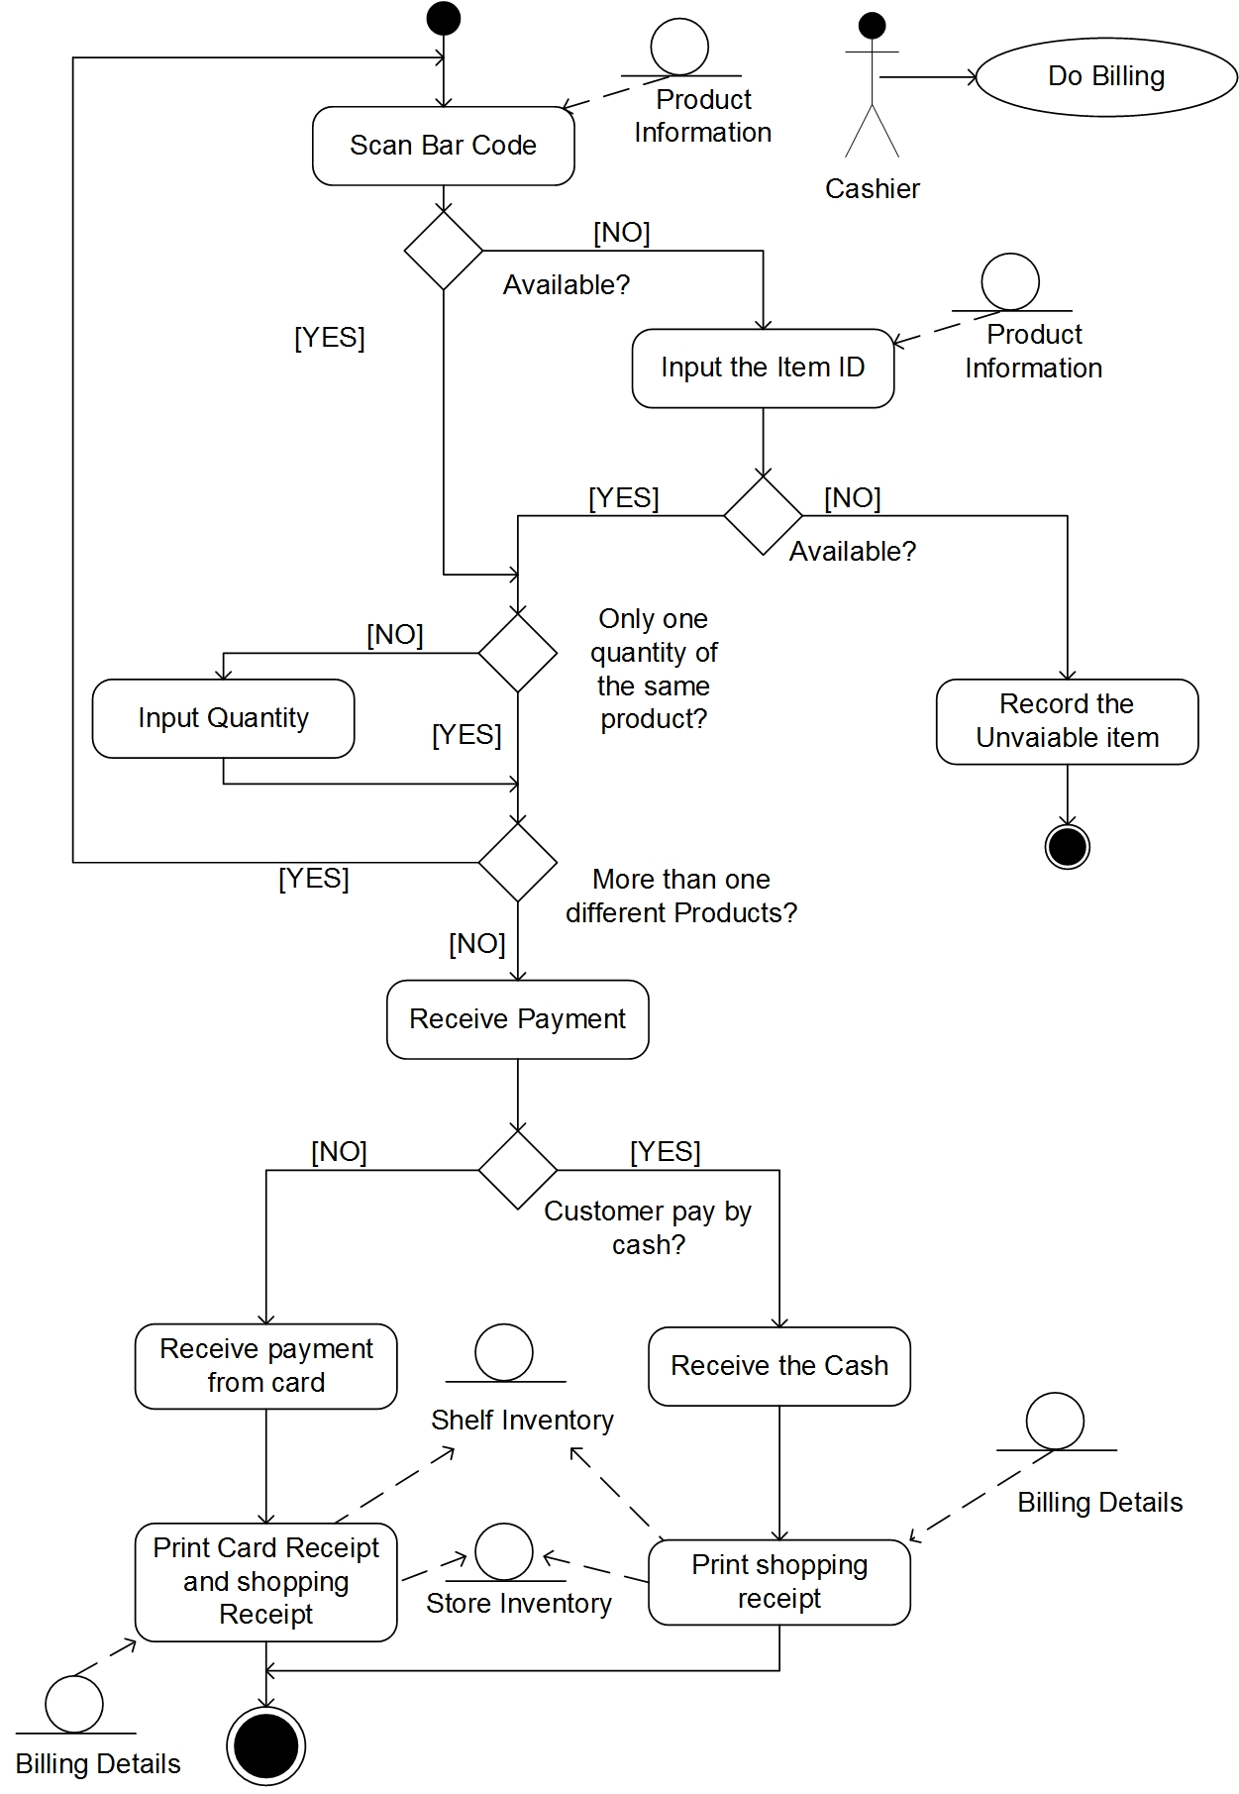

|  |  |
| --- | --- |
| **Use case** | Generate end-of-day sales |
| **Actor** | cashier |
| **Purpose** | To check whether the physical money and the system money is matched and send an email to inform the condition to owner. |
| **Pre-condition** | User will trigger this use case when he got the sales record from cashier. |
| **Post-condition** | The result of whether the physical money tally with the system money will be shown, and if the result is no, an email will be sent to owner to inform him the lost. |

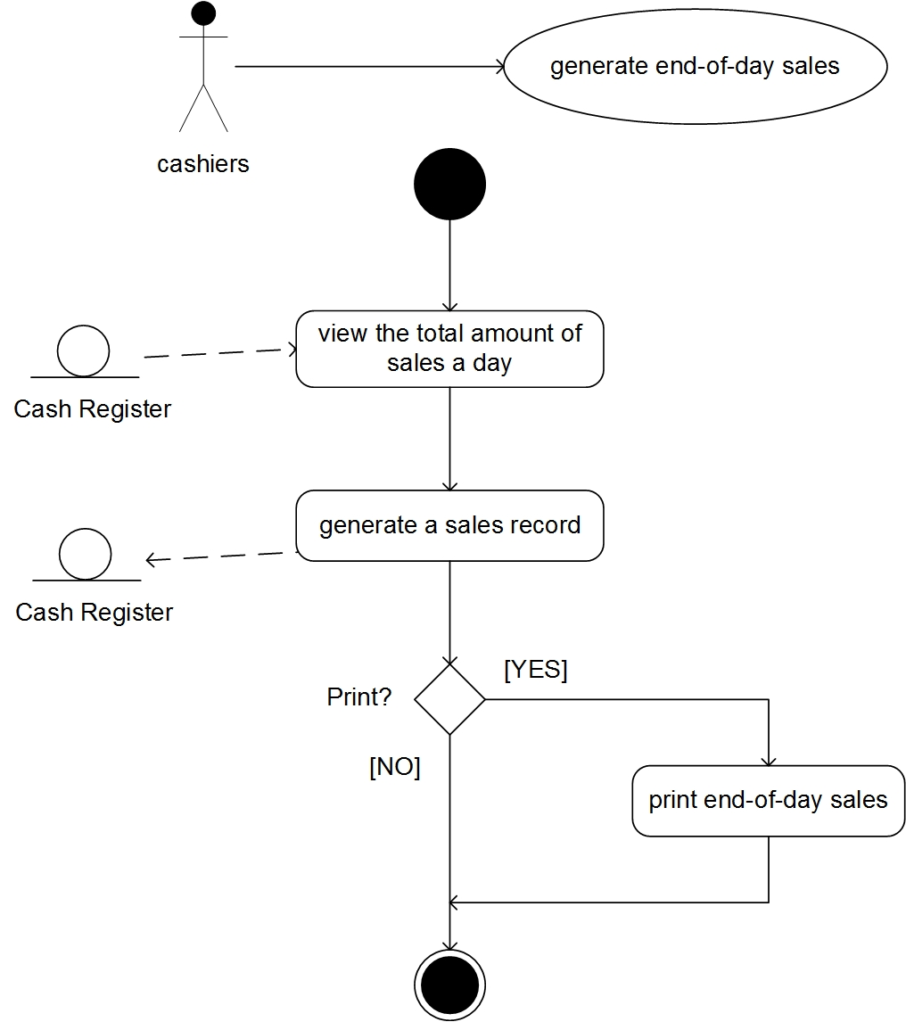

|  |  |
| --- | --- |
| **Use case** | Generate label |
| **Actor** | promoter |
| **Purpose** | To Generate the label with new / changed price. |
| **Pre-condition** | User will trigger this use case when he there is a change in price. |
| **Post-condition** | After the labels are generated the status is updated in price change. |

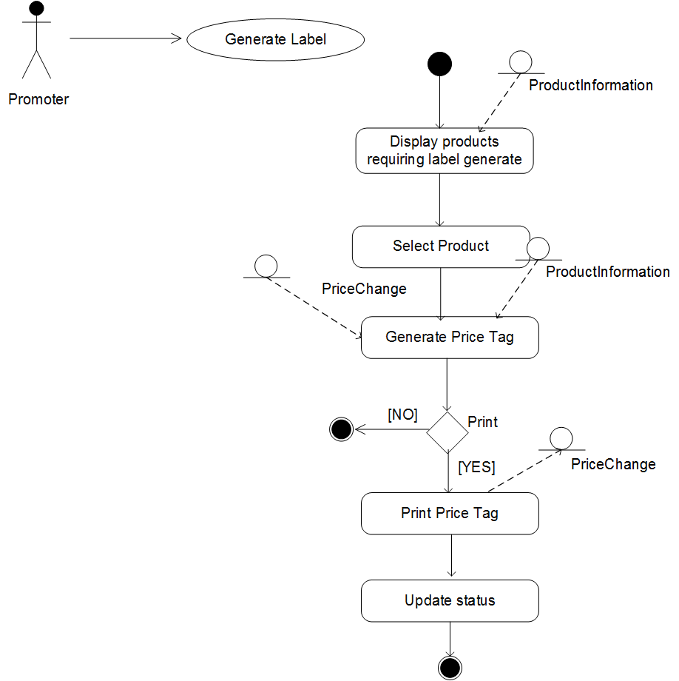

|  |  |
| --- | --- |
| **Use case** | Record damaged/expired goods |
| **Actor** | promoter |
| **Purpose** | To update the shelf inventory, when he sees a damaged product or expired item. |
| **Pre-condition** | User will trigger this use case when he spots damaged or expired products in the shelf. |
| **Post-condition** | Status of the goods is changed. For expired products, status - “Expired”, for damaged products, status – “Damaged” and the shelf inventory is updated. |

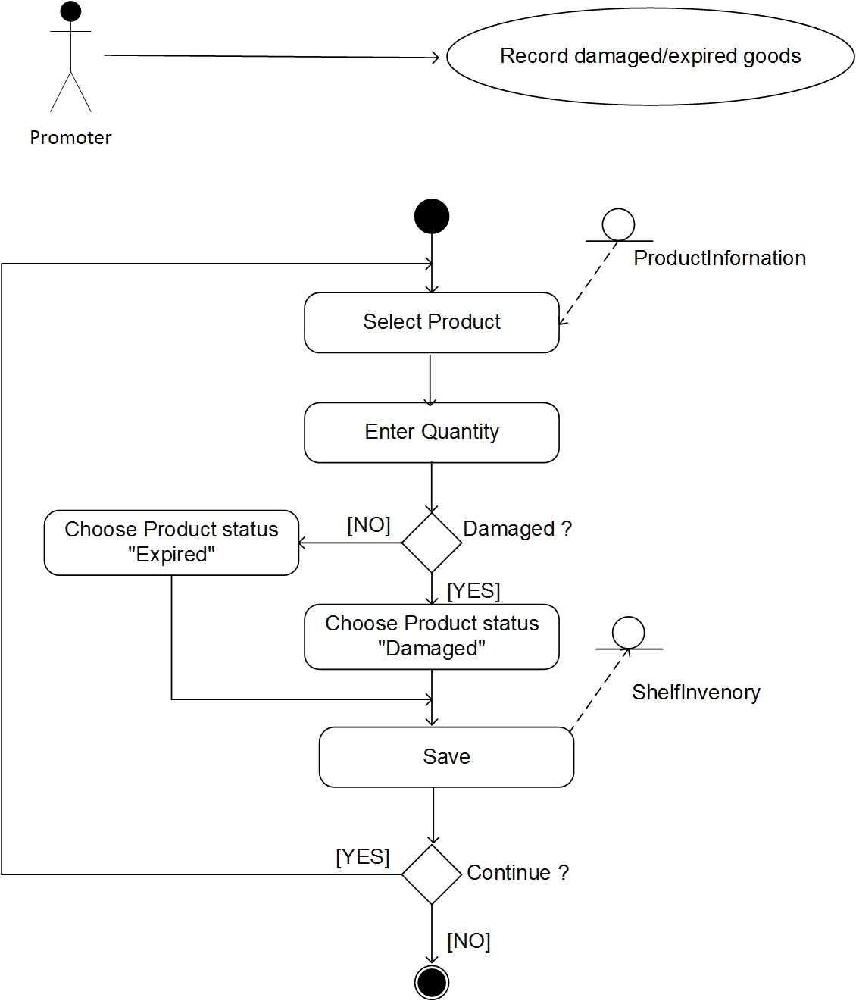

|  |  |
| --- | --- |
| **Use case** | Maintain shelf inventory |
| **Actor** | promoter, store men |
| **Purpose** | To update the shelf inventory, after he receives the products from store and the system will automatically display the products that are running low in shelves and display a list & User confirms the list, to replenish the products. |
| **Pre-condition** | User will trigger this use case when he receives goods from the store and also when he wants to confirm the replenish list. |
| **Post-condition** | Status of the goods is changed. For new shelf inventory, status - “In Stock”, for confirmed replenish list, status – “Low” and the shelf inventory is updated. |

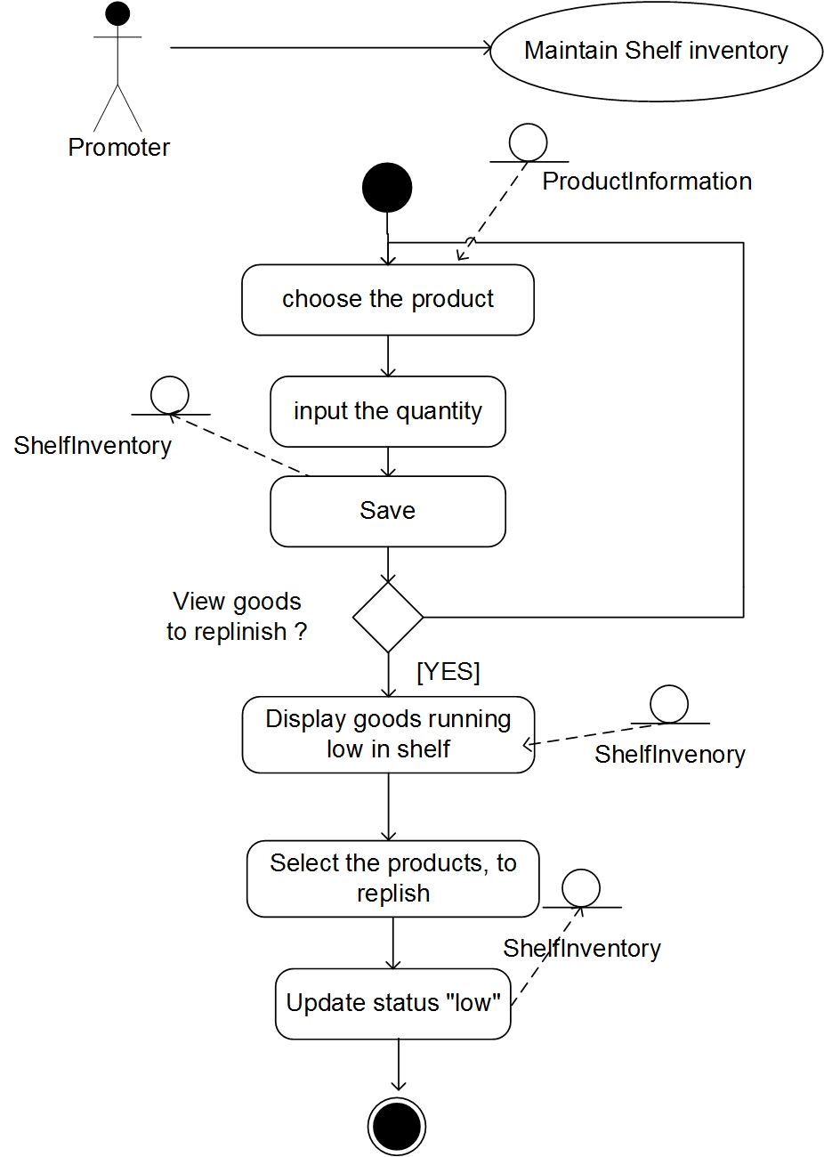

|  |  |
| --- | --- |
| **Use case** | Notify suppliers |
| **Actor** | store men |
| **Purpose** | Send email to the suppliers for damaged or expired goods information |
| **Pre-condition** | User will trigger this use case when he selected the damaged or expired goods. |
| **Post-condition** | The emails which have damaged or goods list, send to associate suppliers. |

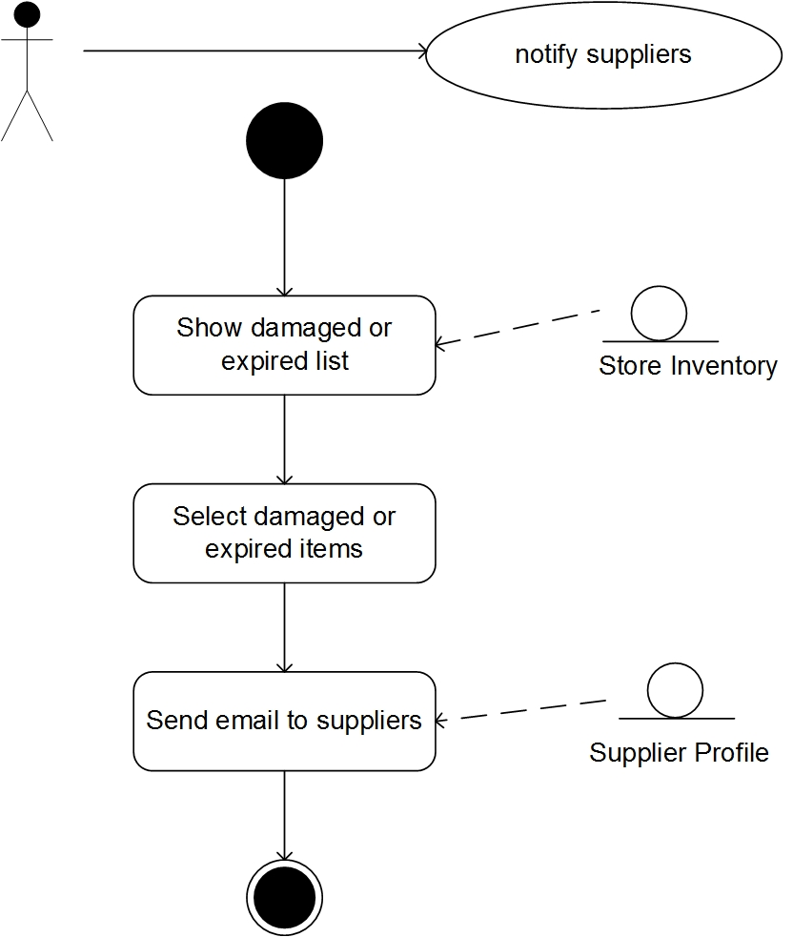

|  |  |
| --- | --- |
| **Use case** | Place order |
| **Actor** | store men |
| **Purpose** | To purchase different goods according to store inventory and product information |
| **Pre-condition** | User will trigger this use case when goods in store are running low |
| **Post-condition** | Choose good need to place and send new order to suppliers |

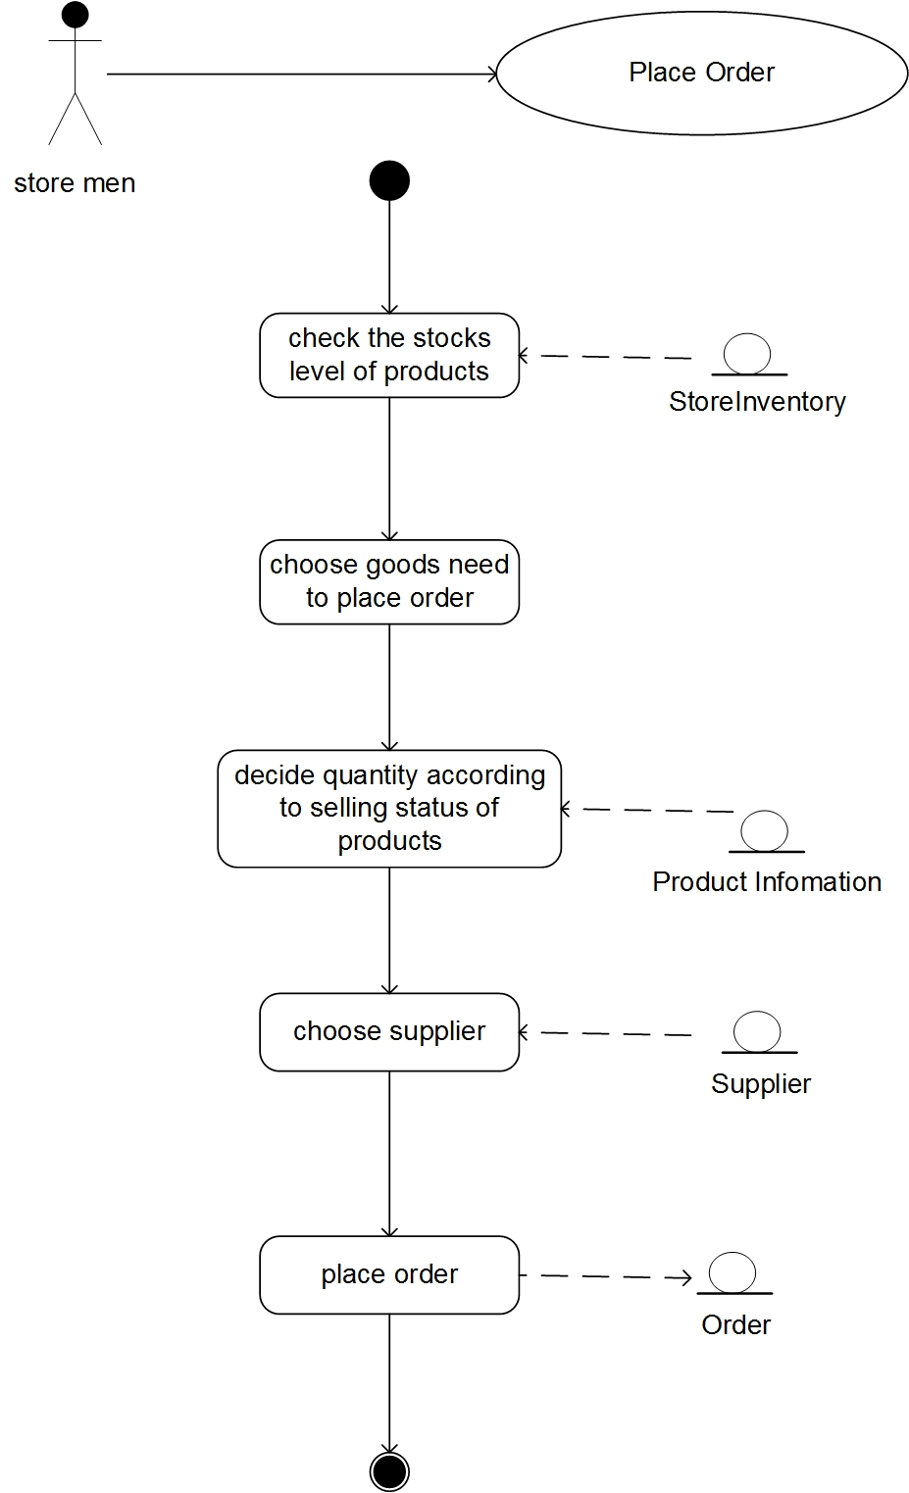

|  |  |
| --- | --- |
| **Use case** | Maintain store inventory |
| **Actor** | store men |
| **Purpose** | To record goods retrieve or arrive. |
| **Pre-condition** | User will trigger this use case when place order or goods on shelf are running low. |
| **Post-condition** | Increase quantities and save into system store database when new goods are arriving, decrease quantities and save into system retrieve database when promoters retrieve goods. |

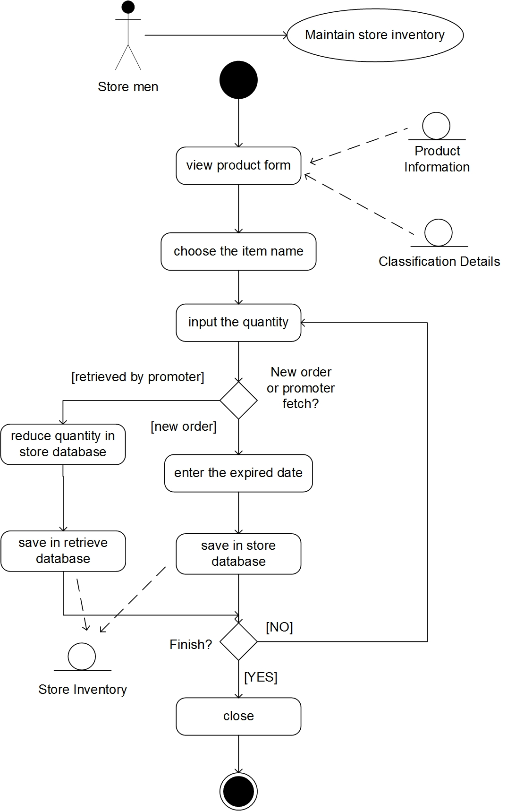

|  |  |
| --- | --- |
| **Use case** | Manage product |
| **Actor** | branch manager |
| **Purpose** |  |
| **Pre-condition** |  |
| **Post-condition** |  |

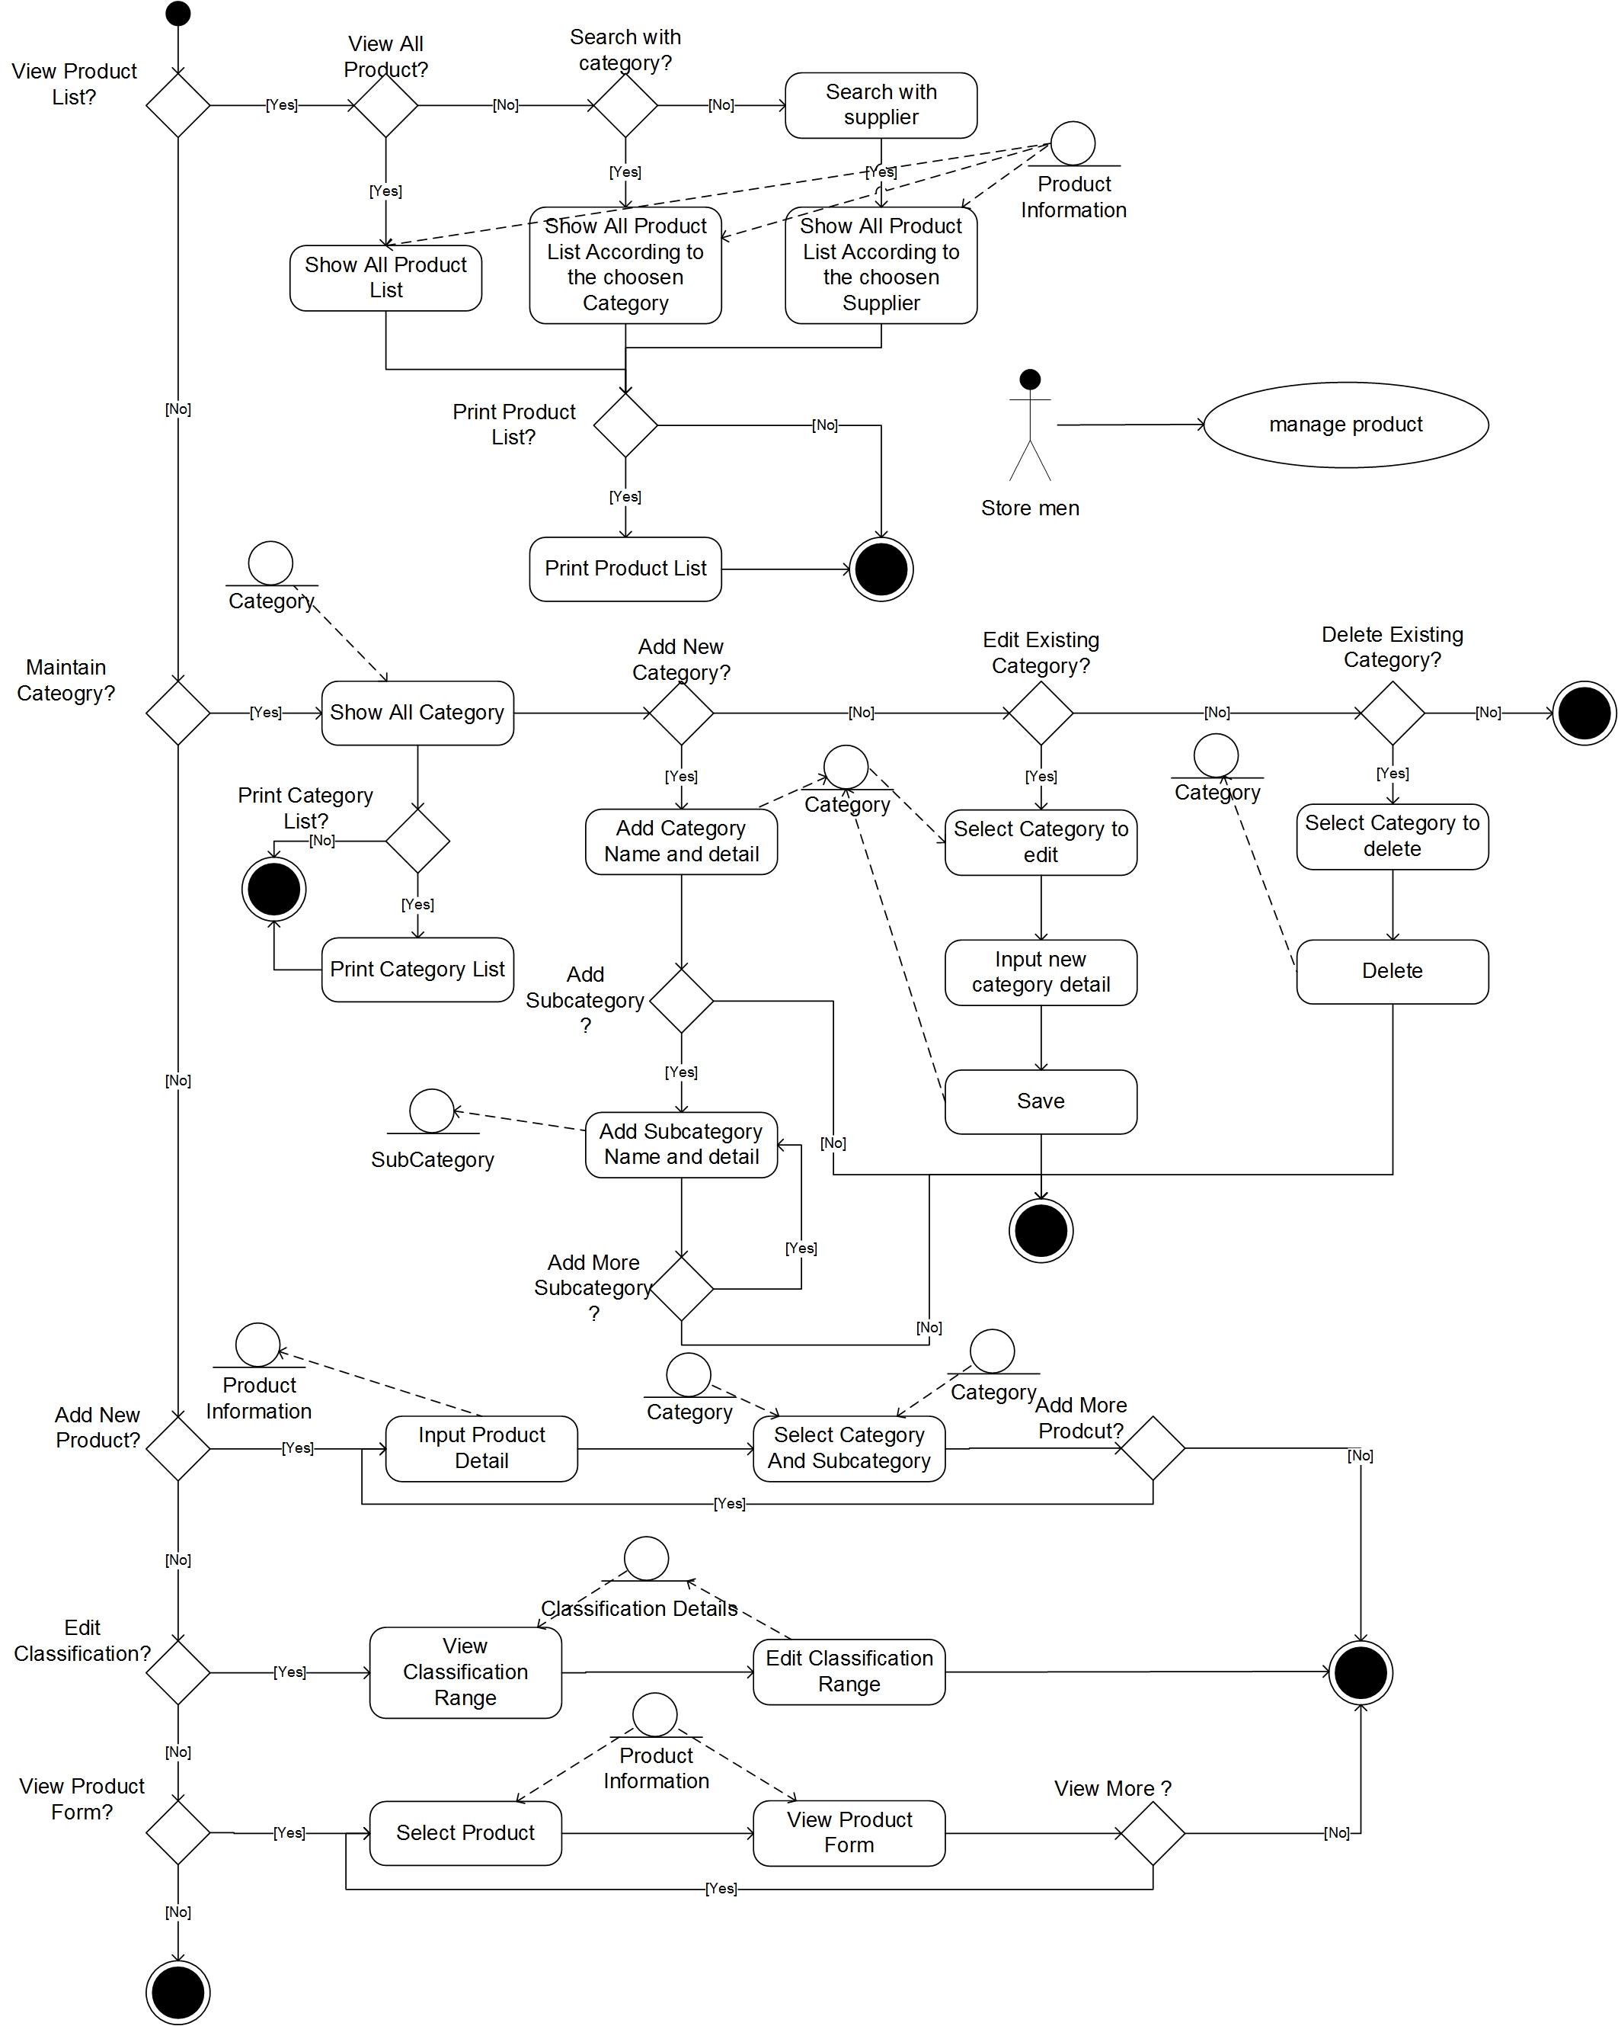

|  |  |
| --- | --- |
| **Use case** | Check sales report |
| **Actor** | branch manager |
| **Purpose** | To generate the end-of day sales report, and send an email to the manager and store man to let them know. |
| **Pre-condition** | User will trigger this use case when the shift is finished. |
| **Post-condition** | The end-of-day sales record will be generated, and an email will be sent to the store man and the branch manager. |

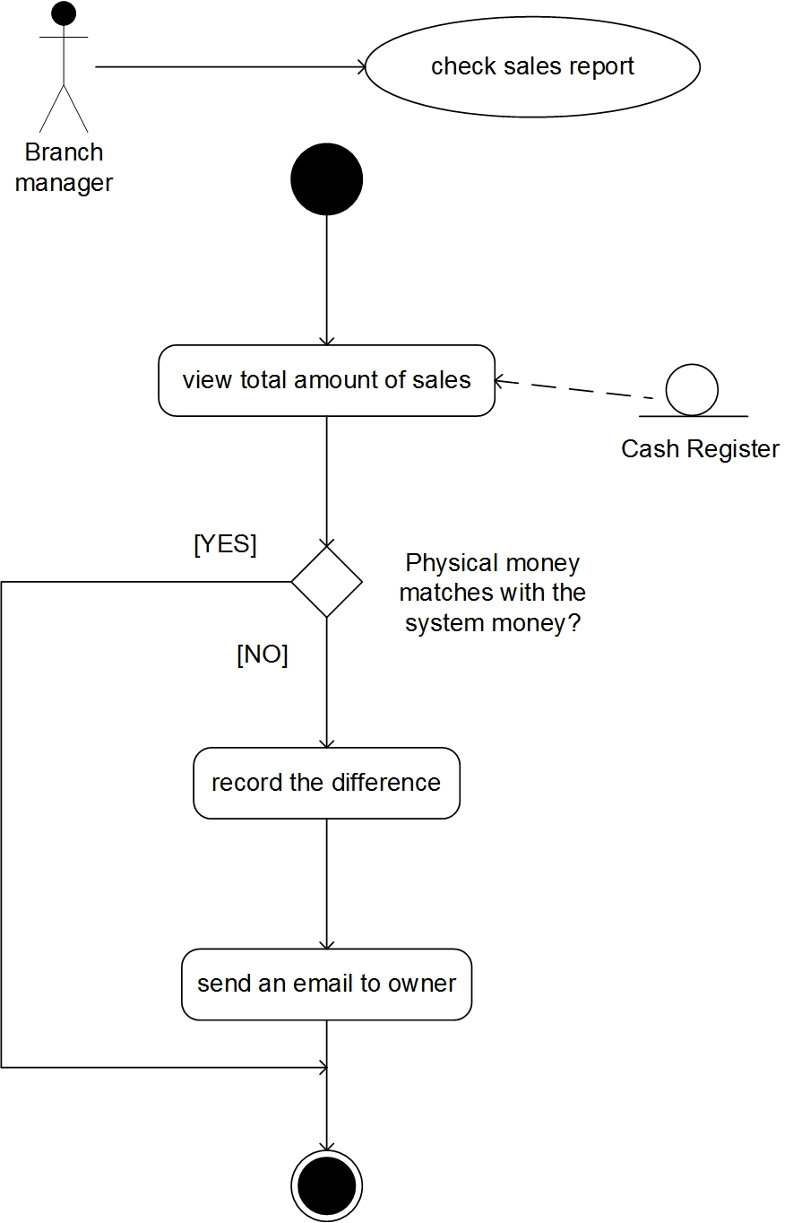

|  |  |
| --- | --- |
| **Use case** | Manage user account |
| **Actor** | branch manager |
| **Purpose** | Allow branch manager to add, delete and edit users’ account. |
| **Pre-condition** | Hire new staff, change users’ profile or fire staff. |
| **Post-condition** | To add new staff profile and create new account, correct user account or delete. |

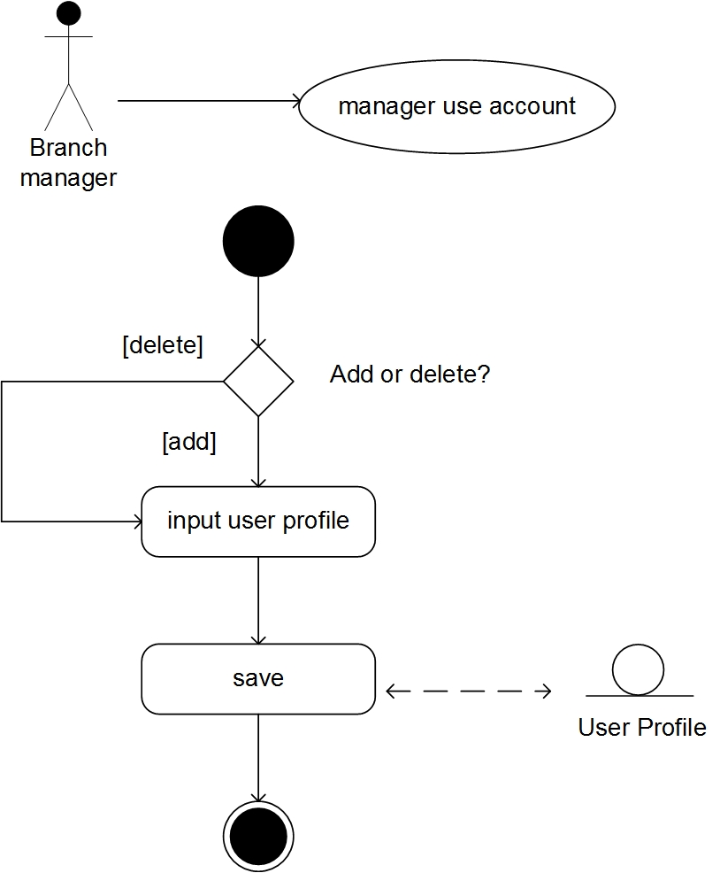

|  |  |
| --- | --- |
| **Use case** | Manage supplier |
| **Actor** | branch manager |
| **Purpose** | To manage different suppliers, add, edit or delete. |
| **Pre-condition** | User will trigger this use case when new suppliers coming, or change suppliers. |
| **Post-condition** | Add new suppliers’ information into system, changer or delete. |

|  |  |
| --- | --- |
| **Use case** | Manage product price |
| **Actor** | owner |
| **Purpose** | To Increase or decrease the price of the products. |
| **Pre-condition** | User will trigger this use case when he receives products from suppliers, if there is a need to change the prize. |
| **Post-condition** | After the prices are changed, they are updated in product table and change price table. Change price table is then used when the user needs to generate new labels for the products. |

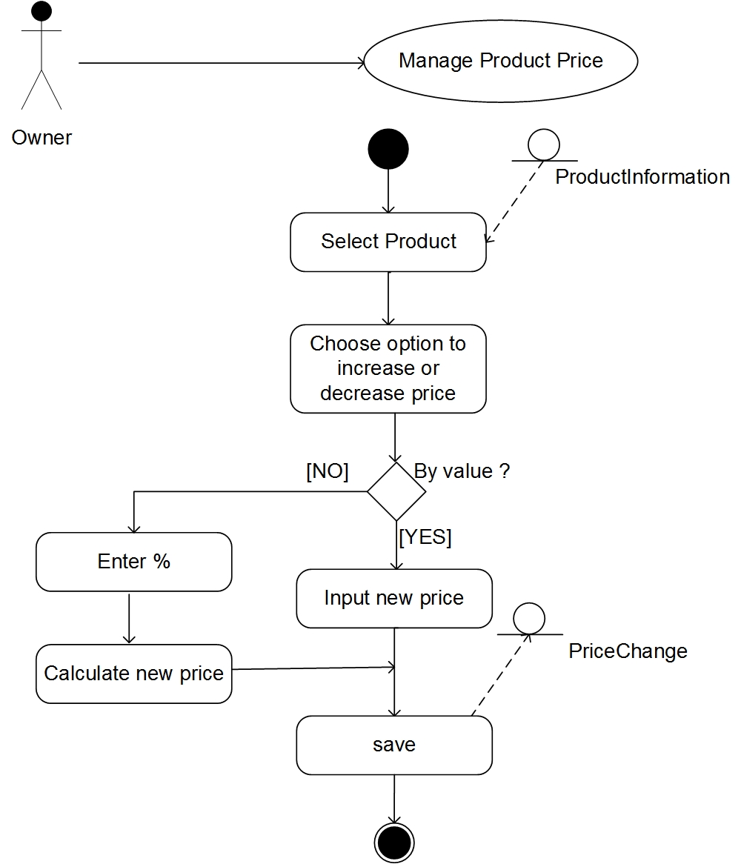

**Class diagram:**

